**Wearable computing vest to detect the proximity of others**

**Darragh Walsh**

**13491612**

Final Year Project – **2017**

B.Sc. Single Honours in

Multimedia, Mobile and Web Development

**(delete where not applicable)**



Department of Computer Science

Maynooth University

Maynooth, Co. Kildare

Ireland

A thesis submitted in partial fulfilment of the requirements for the B.Sc.

Single Honours in Multimedia, Mobile and Web Development. **(Delete where not applicable)**

Supervisor: **Joe Timoney**

Contents

Declaration i

Acknowledgements ii

Abstract iii

List of Figures iv

List of Tables iv

**Chapter one: Introduction** 1

1.1 Topic addressed in this project 1

1.2 Motivation 1

1.3 Problem statement 2

1.4 Approach 2

1.5 Metrics 3

1.6 Project 3

**Chapter two: Technical Background** 4

2.1 Topic material 4

2.2 Technical material 4

**Chapter three: The Problem** 5

3.1 Project UML documentation 5

3.2 Problem analysis 5

**Chapter four: The Solution** 6

4.1 Analytical Work 6

4.2 Architectural Level 7

4.2 High Level 7

E.g. Packages, Class Diagrams, etc. 7

4.2 Low Level 7

4.2 Implementation 8

**Chapter five: Evaluation** 8

Summary 8

5.1 Solution Verification 8

E.g. use your equations to verify the correctness of your solution 8

5.2 Software Design Verification 8

5.3 Software Verification 9

5.3.1 Your test approach (i.e. unit testing, sub-system testing, system testing) 9

5.3.2 Your tests (e.g. scenarios, test cases, test data, etc.) 9

5.3.3 Your test results 9

5.3.4 An interpretation of the results 9

5.4 Validation/Measurements 9

5.4.1 Results 9

5.4.2 Explanation of Results 9

5.4.3 Analysis of Results 9

5.4.4 Comparison with previous solutions (if relevant) 9

**Chapter Six: Conclusion** 10

**Summary** 10

**6.1** **Contribution to the state-of-the-art** 10

**6.2** **Results discussion** 10

**6.3** **Project Approach** 10

**6.3** **Future Work** 10

**References** 11

**Appendices** 12

Appendix 1 Schematic of the hardware associated with this project. 13

Appendix 2 Code developed for this project. 14

Appendix 3 UML Class, Use Case and sequence diagrams for this project. 15

Appendix 4 Screen shots of the project implementation 16

## Declaration

I hereby certify that this material, which I now submit for assessment on the program of study as part of **Multimedia, Mobile and Web development** qualification, is *entirely* my own work and has not been taken from the work of others - save and to the extent that such work has been cited and acknowledged within the text of my work.

Signed: Date:

## Acknowledgements

## Abstract

Improving technology has led to the development of devices in a number of areas and as a result of this, addressing problem areas has become a lot easier. Such a problem is the issue of safety devices and those of which can cater for individuals with visual impairments or loss of vision. Using a variety of outputs, a wearable device using proximity sensors can alert both the user and surrounding individuals to the presence of an obstacle. The problem, providing these different outputs by creating a hardware circuit and converting sensor values to produce some meaningful output. The approach to this project began with researching the problem area as well as previous solutions created and planning how the project would be constructed. Seeing these other projects causes a number of questions to arise, one of the those being, what could be added to make a unique solution? As there are a broad number of output devices available, this left some room for incorporating a number of unique outputs in the form of buzzers, changeable RGB LED’s and possibly tactile output in the form of a vibrating motor. Validating the created solution involved comparing the actual device output against the expected output when an obstacle is within a certain distance.

## List of Figures

Figure 3‑1 UML class diagram overview for this project. 4

## List of Tables

Table 2‑1 Table of interest: Aspect of your implementation 2

Table 2‑2 Data sources used in your implementation 2

# **Chapter one: Introduction**

## 1.1 Topic addressed in this project

The aim of this project is to detect the proximity of other users / objects by using a number of different software and hardware components. Wearable technology can now be used to aid with the detection of an objects in proximity to the user, this project addresses the issue of using proximity sensors and their feedback to alert the user to the presence of some obstacle in their path, however it may also be used to alert surrounding individuals to their proximity to the user of the device. The input to the system is some proximity measurement taken by some ultrasonic sensors and various outputs can be added such as buzzers to include an audible output, as well as LED’s for visual output.

## 1.2 Motivation

The field of assistive technology has been one in which there have been some outstanding developments. In the world, there is said to be approximately 314 million people who suffer with visual impairments[6]. Vision with visual impairments can vary, some cases are more severe than others, some people may have better vision then others, many causes for visual impairments are AMD or Age- related Mecular Degeneration, Glaucoma, Cataracts and Diabetic Retinopathy.[7] All of these have a different effect on the vision, however, this project will aid all forms of visual impairment. This is one of the reasons we’ve seen such an evolution in some branches of assistive technology as we can see there has been a transition from traditional methods of aids like the guide dog and the white cane to the creation of the tactile wand(image) which uses sensors and a tactile response to alert the user to obstacles. However, introducing the use of wearable technology opens up a broad range of possibilities with regards to usability, comfort and so on. Wearable technology has proven to be useful in many different fields. Embedding sensors and such to items of clothing and wearable devices such as watches has become increasingly popular. The developments in the wearable area can be used to aid those who are visually impaired, for example, using come ultrasonic proximity sensors input to alert the user when an obstacle / individual is in front of or behind them, different pitches and LED outputs can be used to indicate different distances from the sensors. Progression in the wearable technology such as the creation of wearable microcontrollers has provided a way to alert users to their surroundings can prove to be extremely beneficial in aiding those who are visually impaired. This project can provide both a visual and audio representation of proximity to objects for the benefit of an individual. This is an issue which we should look at addressing so that we can develop and present interesting and useful technologies which build upon our current technology. Not only is this an aid for the visually impaired but it is also a safety device, ensuring that other people are made aware of this person through the different LED and buzzer outputs. Although the main task is to create a functional application, using these different aspects of output can create aesthetically pleasing products which offer a function, this is seen through the use of the different coloured LED’s. On that point, using the LED’s can visually represent a state and create an understanding within individuals who do not know what such a product is used for.

## 1.3 Problem statement

As discussed in the motivation for creating such a project, the programming and the use of several hardware components which use digital or analogue feedback were used to implement the several blocks of functionality this project required. A number of technical problems were to be addressed while developing this project. An example of such is converting the input signal from the proximity sensors and converting them to some sort of meaningful measurements by which we can establish the distances from obstacles to the proximity sensors to control the different outputs and thus controlling these different outputs to provide a meaningful representation of the different states. An example of such in this project would be using pulse width modulation and taking the input and convert it to inches or centimetres, something which helps to differentiate outputs the way which we want to. A challenging aspect is also programmatically describing the different output devices and in turn integrating them to carry out the functions we wish.

## 1.4 Approach

When beginning to look at this project, there were are a number of steps to be carried out. Firstly, looking for examples of previous projects in similar fields, using sensors to calculate proximity and look at its various uses. Based on the information gathered, deciding at what kind of market this project would be aimed at was essential. After looking at a number of projects, choosing a safety device for the visually impaired was both interesting and would add to the depth of assistive technology there is in this area.

Then came the question, what does this project need to do and how is it going to do it? As the project must be a wearable vest, it was important to look for and find a wearable platform to which we could upload a software solution to and it would receive some inputs from proximity sensors in a way which we can define and then produce a corresponding output using connected output devices. The Arduino platform would provide this open source platform for the software solution.

This project must use proximity sensors and output devices to alert the users to the proximity of other people / obstacles. To achieve this, it was important that the sensors chosen had an extensive range so to allow for alerts to the users in plenty of time. As a result of this, ultrasonic sensors seemed to be the most appropriate option. Having a sensor only at the front of the vest, was thought to be leaving the user vulnerable to obstacles behind them so the decision was made to include two sensors. Two ultrasonic sensors were chosen, the MB1010 LV-MaxSonar-EZ1 by Maxbotix and the HC-SR04 which boast an extensive range of over 5 metres. It was also important that both of these hardware components were compatible with the FLORA microcontroller and could be integrated into the wearable project.

Choosing output devices was a crucial part of the process. These devices are an integral part of the functionality, if an obstacle is detected, these devices will alert the user to it. Both a visual and audible form of output were to be included. For an individual who is visually impaired, audible outputs will warn them to the danger. Visual outputs in the form of LED’s could also work in the same way, providing a specific output depending on the distance of an object from the sensor. This will provide a warning for surrounding individuals as well.

Before creating the wearable, it was important to test out the project with a hardware prototype using alligator clips to examine the outputs and the behaviour of each aspect of the code and of the hardware circuit. Basic testing could be carried out at these face moving objects in front of the sensors. When happy with the functionality of the project, integration with the wearable could be done using conductive thread, increasing how wearable it is and reducing the amount of loose wiring. Testing of the finished product could then be done by walking through a set course, and comparing the output of the project to the expected output.

## 1.5 Metrics

To achieve success in this project, it’s all about the accuracy of the proximity sensor and the corresponding state of the output. For example, if an object is within a meter of the sensor, the outputs must provide an alert to notify the user of this, such as the buzzer emitting sound and the LED turning red in colour. To evaluate how well this project works, the vest can be tested by walking a path in which there are a number of obstacles / other people and judge how well its working by checking the LED’s current output against the output expected.

## 1.6 Project

Before working on this project, I had no experience with the area of developing wearable devices and using Arduino. However, this project allowed me to delve into this side of programming and development. Although I had previous experience of coding with C/C++, it was interesting to discover another way in which C/C++ is used. The project has also introduced me to the world of Adafruit and wearable microprocessors and how to integrate such hardware with all manner of sensors and different output devices.

Working with hardware devices is an area of development which I haven’t had much experience with. However, this project afforded me the opportunity to work with the FLORA wearable microcontroller. Interfacing the sensors and different outputs with the microcontroller, this also included integrating this hardware circuit with the vest. This included the use of conductive thread and also some soldering, which I also have not got much exposure to.

Whilst working on and researching this project, I got a greater understanding of what areas such technology can be used for and an in depth look into different problem spaces with regards to visual impairments. As a result of this, developing a solution for this problem space allowed me to get a better understanding of how different sensors work and decision making to create an optimal solution.

* Interfacing the sensors with the microcontroller
* Specifying different outputs for different sensor readings
* Integrating the circuit with piece of clothing
* Understanding of how the different sensors work

# **Chapter two: Technical Background**

## 2.1 Topic material

Before creating this project, it was essential to look at what similar projects already exist in this area, whether it be a project which already exists to solve the problem wish to solve, or projects which provide ideas to include in the finished project. There are an endless amount of papers and articles on the topic of proximity sensing, from work on sanitiser dispensers to Vehicle proximity sensors for detection at the rear of the vehicle. It is clear that the use of such sensors is widespread and used for a variety of purposes.

An example of such a project which is a Proximity detector for the visually impaired [1] and looks at implementing a similar solution using ultrasonic sensors on a pair of glasses for obstacle detection at eye level. This project seems to be looking to cater for a similar demographic as this project does. It uses a variety of methods to output the sensors’ information through audible and tactile output. It shows how with a subject such as proximity sensing to aid the visually impaired, there a number of variations and spins which can be taken, seen in position of sensors and types of alert, all resulting in an effective tool. Ultrasonic sensors seem to be quite useful in similar projects I have been researching, however one thing I have found to be variable is the output or alert. In this Multidimensional Walking aid, voice guidance is used.[7] Although this may be similar, by using an audible alert, the use of voice guidance is something different.

Another project found during the research phase saw an infrared sensor providing sensor readings and a microcontroller providing corresponding visual outputs. This was used for cyclists who could put this wearable on their back and the LED’s would alert for example a driver behind the cyclists to their proximity to the cyclists. This is an example of using a similar wearable for safety. This would be similar to the project which I was working on, only instead of focusing on just behind the user, the vest will detect obstacles in both in front and behind the user and provide a number of outputs.

## 2.2 Technical material

On beginning this project, research into different uses of wearable microcontrollers which were compatible with Arduino was carried out. Arduino is an open source which allows for creating interactive electronic objects. Using the Arduino IDE was simple and included a number of sketches and examples which can be tested on the microcontroller. Code in Arduino is mainly C/ C++, which I have previous experience with so this helped and with many of the hardware components, there were many downloadable libraries to needed to code for these components. An advantage of using Arduino is the wide community who create projects and provide answers to any questions that any relative beginners or anyone at all may have. This is facilitated through a well set up forum section on the Arduino website.[2]

Some of the hardware used to make this project came from Adafruit[3] who are an open source hardware company that design, manufacture and sell electronic components. Adafruit was found to be extremely informative, since a lot of their products are Arduino compatible, there are countless number of tutorials and blog posts, some of which were extremely helpful. From getting started with using the FLORA [4] to adding a number of Smart Neopixels, Adafruit provided the basis for manipulating the visual LED output in the project. As well as providing code examples, in depth technical details were also provided by Adafruit and those who are relatively unexperienced with regards to the circuitry aspects of the project this was of great assistance. Much like Arduino, Adafruit has built a community around people using their products and sharing their experience and showing what can be done with such products, delving into this material provided different ideas and thoughts.

When it came to working with the proximity sensors, both Arduino tutorials and the sensors’ datasheets were used to find the technical details such as circuit diagrams, sensor beam patterns and some background information. [5] This helped when designing the circuit and provided some information when it came to the code, knowing what kind of distance values are expected.

# **Chapter three: The Problem**

**User requirements:**

* System must be integrated to a wearable vest which when worn does not cause any malfunctions with the circuit causing the sensors to give false readings.
* Must include one or more sensors, to detect the proximity of the user to an obstacle / other individual.
* Must provide a visual output (using LED’s) and an audible output (using piezo buzzer) corresponding to the reading from the sensor. Red, yellow and green depending on how close the object is, blue if there is an obstacle behind them and some other colour(tbd) when there is an obstacle both in front and behind.
* Must be able to distinguish between an obstacle being detected to the rear of the individual versus to the front of the individual (Different visual and audible outputs)

## 3.1 Project UML documentation

Provide any model(s) of the problem (e.g. equations, ERD’s, UML Use Cases & Scenarios, Activity Diagrams, etc.)

## 3.2 Problem analysis

Working on this project, there was one major issue to overcome, taking readings from a sensor and converting that into some for which can be used to alert the user to the presence of some obstacle but it is also important that this project is easily usable and wearable. Need to convert the readings from the sensor to some sort of meaningful output both visual and audible. Using the pulse width modulation of the sensors, each 147 microseconds it takes for the wave to come back to the sensor corresponds to an inch. This is the basis for deciding for example, what colour would be displayed on the LED and what frequency would played with the buzzer. Of course these will vary with the different measurements of distance. This will aid not only the user but it also creates an awareness and an understanding in the surrounding individuals. As there are multiple sensors, there is a need to account for multiple inputs in the conditional statements of the code for this program. With the addition of sensors comes the introduction of added complexity, for every one of the multiple sensor states, there must be a corresponding response from the outputs to the sensor readings. In this project there are sensors on the front of the vest and on the back respectively. There must be a specific output for examples when there are obstacles detected by both sensors it will have a corresponding output. It is important that the vest is wearable and flexible to the movement of the individual. Using the conductive thread means that the number of loose wires are reduced. A lot of the hardware components allow for integration with clothing with small holes to tie to the clothes. The vest must be comfortable and constructed in such a way that sensors and outputs are not easily obstructed which of course would affect how it worked.

# **Chapter four: The Solution**

Throughout the process of this project, a number of decisions were to be made to resolve the problems defined in the previous sections. From the choice of hardware such as sensors and buzzers. The sensors are used to detect obstacles within certain distances, the distance chosen for the LED to turn red and the buzzer to sound was one metre. This however is easily changed in the conditional loops of the code and due to the microcontroller containing a micro-usb port, the program is easily uploaded to the circuit.

## 4.1 Analytical Work

The extent of analytical work in this project only went as far as reading returned data from the proximity sensors and converting these values to a form which could be used throughout the program to control what outputs were activated. The sensors returned a value in microseconds, every 147 micro seconds corresponds to an inch, which was then converted to centimetres.

## 4.2 Architectural Level

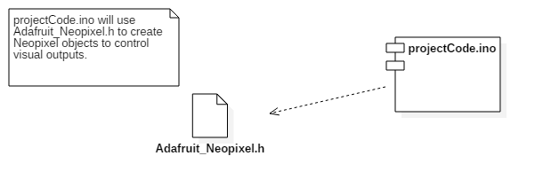

Component diagram.

E.g. Implementation Diagrams

## 4.2 High Level

## E.g. Packages, Class Diagrams, etc.

## 4.2 Low Level

**Setup()** :

This method is one which must be included in the Arduino code. In this case, the setup method defines what different outputs and inputs we have and at what pins they are located. It will also begin the display of the NeoPixel LED.

**Loop()**:

Loop() will continuously run any code which is specified inside of it. As a result of this, the process of checking both sensors can continuously be done by calling the Read_front_sensor() and Read_Back sensor() methods. Within this loop method , conditions are also set for when to call the method Ultrasonic() and when to call the method PWM(). These use the different sensor readings to determine what output is used.

**Read_front_sensor()**:  
This method contains the functionality for reading values from the Maxbotix sensor on the front of the vest. This will also convert the sensor readings from microseconds to the unit of measurement inches and then to centimetres. The sensor measures how long it takes for signal sent out to return to the sensor, 147 microseconds corresponds to one inch.

**Read_back_sensor()**:  
Read_back_sensor() will contain the functionality for reading the values from the HC-SR04 sensor on the back of the vest. Much like with the front sensor, this sensor will measure in microseconds, how long it takes for the signal to return to the sensor. Once we receive this measurement, it can be converted to centimetres.

**Print_range()**:

While creating this project, it was important to know what sort of values the sensors were returning. This method printed these values to the Serial monitor so for development purposes, the returned sensor values could be known and understood.

**PWM()**:

This method includes the functionality to set the colour of the output LED and the frequency of the buzzer to certain values when an obstacle is detected by the sensor on the back and the obstacle is within a meter of the sensor.

**Ultrasonic()**:

Ultrasonic() will be include the functionality for setting the colour of the output LED and the frequency of the buzzer. Ultrasonic will decide whether the LED will be Green, yellow or red. If an obstacle is detected within a meter of the front sensor, Ultrasonic() will set the LED to red and cause a buzzer output. Ultrasonic is the default method to be called.

## 4.2 Implementation

Discuss anything interesting here; put full source code in an appendix or attachment

# **Chapter five: Evaluation**

## Summary

This chapter describes how the solution to the defined problem is evaluated, how the design of the solution worked, how a correct solution is defined and validated.

## 5.1 Solution Verification

In terms of verifying the final solution, it was all about testing the completed project, did the LED’s and the buzzer output the correct output, which is specified in the code. The distances at which the certain outputs occurred is easily changed within the conditional statements of the code.

## E.g. use your equations to verify the correctness of your solution

## 5.2 Software Design Verification

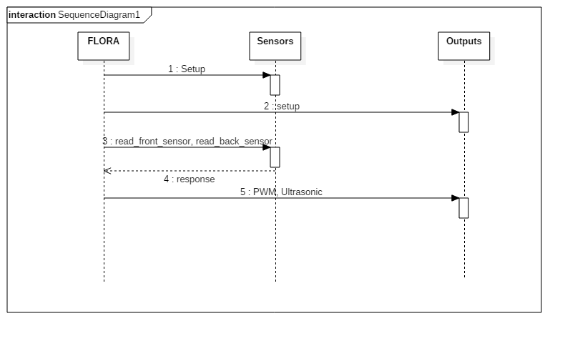Using a model of your solution. E.g. use UML interaction diagrams to verify each scenario.

## 5.3 Software Verification

How did you demonstrate your software worked properly?

To show the software works, we must look towards both the readings of the sensors in the serial monitor and the hardware outputs. There is prior knowledge of what the output of both the LED’s and the buzzers should be. These are specified in the code.

If you have not tested your software, then you cannot rely on your results. Clearly describe:

### 5.3.1 Your test approach (i.e. unit testing, sub-system testing, system testing)

- System testing is the most appropriate form of testing to carry out with this hardware project

- Does the system deliver on all of the specifications and the functional requirements?

- Non functional requirements, the projects usability?

- Adding lines of code, testing it.. if that works, add next part

### 5.3.2 Your tests (e.g. scenarios, test cases, test data, etc.)

### 5.3.3 Your test results

### 5.3.4 An interpretation of the results

## 5.4 Validation/Measurements

The solution is shown to be working if it outputs the correct thing depending firstly on whether there is an obstacle detected and then the proximity of that obstacle to the sensors. Different outputs will occur depending on the distance from the sensor.

If an obstacle is detected within 1 metre of the front sensor, pulse red and buzz the buzzer, if there’s an obstacle detected between 1 and 2 metres from the front sensor pulse yellow, else pulse green. If an obstacle is detected within a metre of the back sensor (and none detected by the front sensor) pulse blue and buzz the buzzer. If an obstacle is detected within one metre of the front sensor and another within one metre of the back sensor, pulse some unique colour and buzz the buzzer.

### 5.4.1 Results

### 5.4.2 Explanation of Results

### 5.4.3 Analysis of Results

### 5.4.4 Comparison with previous solutions (if relevant)

**Chapter Six: Conclusion**

**Summary**

Chapter 6 identifies and discuss the implications of your work.

Implications of my work: Provides an aid, for the proximity of obstacles and as a safety aid for both the user of the vest and the passer by.

**6.1 Contribution to the state-of-the-art**

If you made a contribution to the state-of-the-art, clearly identify it here.

**6.2 Results discussion**

For desirable results, the outputs of the circuit should have a specific output depending on the distance of an obstacle from the sensor. Testing the system included comparing the actual device output to the expected outputs which were defined in the program. Because it is a safety device, it is important that the system is consistent in its outputs. Each particular case of an object being detected should have a correct corresponding output. There are a number of factors however, that may threaten validity of results. Obstruction of sensors by for example, the users’ hair, can cause the system to output an invalid result even though there may not be an obstacle in the path of the user. Another factor may be the circuitry. Over time, circuitry may become faulty and some connections may weaken, resulting in false outputs.

**6.3 Project Approach**

Discuss your project approach

**6.3 Future Work**

Discuss future work, based on what you have done (and not done)

Adding an array of sensors to provide different ways of measuring proximity, adding some more outputs such as a vibrating motor for tactile output. Integrating the circuit with different clothing. Adding some accelerometers for detecting rapid movement of the user such as falling. Adding more proximity sensors.

# **References**

<http://www2.ensc.sfu.ca/~whitmore/courses/ensc305/projects/2011/21prop.pdf>

<https://forum.arduino.cc/> [2]

<https://www.adafruit.com/> [3]

[https://www.adafruit.com/products/659 [4](https://www.adafruit.com/products/659%20%5b4)]

<https://learn.adafruit.com/>

<https://www.sparkfun.com/products/13959>

<https://learn.adafruit.com/conductive-thread/tools-and-supplies?view=all>

[http://www.maxbotix.com/Ultrasonic_Sensors/MB1010.htm [5](http://www.maxbotix.com/Ultrasonic_Sensors/MB1010.htm%20%5b5)]

<https://www.google.com/patents/US5229975>

<http://www.mecs-press.org/ijisa/ijisa-v6-n8/IJISA-V6-N8-6.pdf> [7]

<http://www.hse.ie/eng/health/az/B/Blindness/> [6]

<http://www.tuvie.com/wp-content/uploads/wand-for-blind2.jpg>

<http://www.ashlowvision.com/resources/visual-impairment-causes-age-related-macular-degeneration-glaucoma-diabetic-retinopathy.118.html> [8]

**Appendices**

Include here all extra material, e.g. your source code, project management (optional) including: the task list, Gantt Chart diagrams (or equivalent), discussion of any significant deviations from plan, and how you managed them, discussion of what you would do differently if you repeated the project.

## Appendix 1 Schematic of the hardware associated with this project.

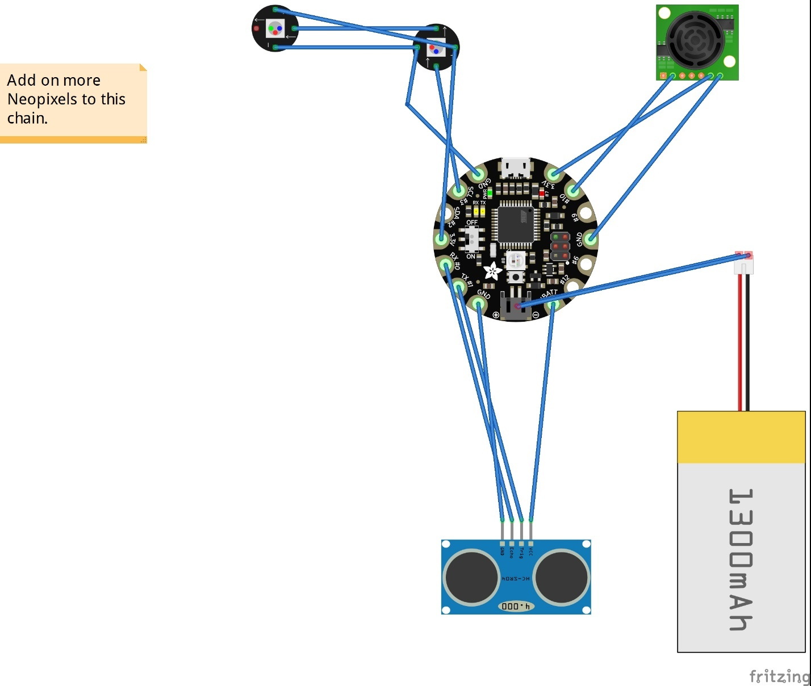

## Appendix 2 Code developed for this project.

## Appendix 3 UML Class, Use Case and sequence diagrams for this project.

|  |
| --- |
|  |
| Appendix 4 Screen shots of the project implementation |
|  |